DP2 2023-2024

Planning and Progress report

**Acme Software Factory**



## Repository: <https://github.com/rafcasceb/Acme-Software_Factory-C1.049>

# Members:

* Castillo Cebolla, Rafael rafcasceb@alum.us.es
* Flores de Francisco, Daniel danflode@alum.us.es
* Heras Pérez, Raúl rauherper@alum.us.es
* Mellado Díaz, Luis luimeldia@alum.us.es
* Vento Conesa, Adriana adrvencon@alum.us.es

# GROUP C1.049

## Version 1.0

16-02-24

Content Table

Repository: https://github.com/rafcasceb/Acme-Software_Factory-C1.049 1

Members: 1

GROUP C1.049 1

Version 1.0 1

Abstract 3

Revision Table 4

Date 4

Version 4

Description of the changes 4

Sprint 4

Introduction 5

Contents 5

**Part I. Planning** 6

7

7

**Part II. Progress.** 8

Conclusions 9

Bibliography 10

# Abstract

In this document, the initial planning and estimation of the individual requirements regarding the deliverable D01 and their progress and final status will be addressed, along with the cost estimation.

# Revision Table

|  |  |  |  |
| --- | --- | --- | --- |
| Date | Version | Description of the changes | Sprint |
| 16/02/2024 | 1.0 | * Initial version of the document | 1 |
| 17/02/2021 | 1.1 | * Screenshots added. * Real cost calculation. | 1 |
|  |  |  |  |
|  |  |  |  |
|  |  |  |  |
|  |  |  |  |

# Introduction

This document will include two different parts: an initial planning of the individual requirements related to the deliverable D01, and an estimation of the final resources dedicated and the comparation with the initial planning.

The structure of this document and the parts included have been determined following the guidelines provided in the Virtual Learning platform, in the document called “08 Annexes”.

As part of the work to be done regarding “Acme Software Factory”, the individual work consists in a technical requirement and two documentation requirements. This document is part of the mentioned documentation requirements, along with a “Analysis” report document.

For the calculation of the cost, the following amounts are considered:

|  |  |
| --- | --- |
| **Role** | **Cost (€ per hour)** |
| Manager | 30 |
| Analyst | 30 |
| Developer | 20 |
| Tester | 20 |
| Deployer | 20 |

# Contents

## **Part I. Planning**

Task listing

***Mandatory***

Modify the anonymous menu so that it shows an option that takes the browser to the home page of your favourite web site. The title must read as follows: “〈id-number〉: 〈surname〉, 〈name〉”, where “〈id-number〉” denotes your DNI, NIE, or passport number, “〈surname〉” denotes your surname/s, and “〈name〉” denotes your name/s.

Estimated time: 25 min.

Final time inverted: 15 min.

***Supplementary***

Produce an analysis report.

Estimated time: 30 min.

Final time inverted: 55 min.

Produce a planning and progress report.

Estimated time: 50 min.

Final time inverted: 1h 10 min.

Visual distribution of tasks.

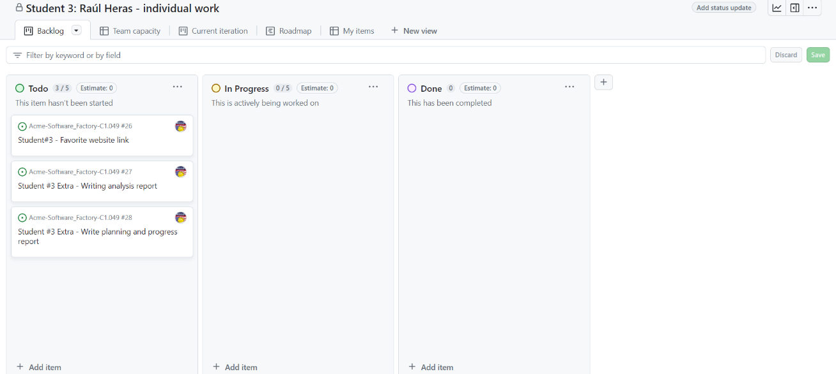

# 

Estimated initial budget.

Time estimated by role:

Developer role**:** 25 min

Analyst role: 1h 20 min.

Estimated personnel cost.

Developer role: 8.33 €

Analyst role: 40 €

Amortization cost.

The amortization will be calculated using a linear method over the span of three years, and only the equipment (the computer) will be considered.

Amortization = (equipment value + residual value) / 3 years = (700 + 0.07*700) / 3 = 749 / 3 = 249.67 €

Total cost.

Personnel cost + Amortization cost = 40 + 8.33 + 249.67 = 297.67 €

## **Part II. Progress.**

Final cost.

Final time by role:

Developer role**:** 15 min

Analyst role: 2h.

Estimated personnel cost.

Developer role: 5 €

Analyst role: 60 €

Amortization cost.

The amortization will be calculated using a linear method over the span of three years, and only the equipment (the computer) will be considered.

Amortization = (equipment value + residual value) / 3 years =

= (700 + 0.07*700) / 3 = 749 / 3 = 249.67 €

Total cost.

Personnel cost + Amortization cost = 60 + 5 + 249.67 = 314.67 €

Budget comparison.

|  |  |  |  |  |  |  |  |
| --- | --- | --- | --- | --- | --- | --- | --- |
| **Role** | **Planned time** | **Actual time** | **Time difference** | **Planned cost** | **Actual cost** | **Difference** | **Amortization** |
| Developer | 25 min | 15 min | -10 min | 8.33€ | 5€ | +3.33€ | 249.67€ |
| Analyst | 1h 20 min | 2h | +40 min | 40€ | 60€ | +20€ | 249.67€ |

This gives us an overall difference of +65 €

Conflicts.

No remarkable problems have arisen in this delivery. Although the technical requirement, which involved taking a developer role, was correctly estimated, the analyst part, involving both “Analysis” and “Planning and Progress” report, was underestimated at first, resulting in an increase in time invested and therefore, the cost.

This was probably due to the lack of experience in this field, as I have not produced similar documents in the past, and I had to grasp the structure and contents of them as indicated in the “08 Annexes” document, provided by the lecturers.

Progress record.

Raúl Heras Pérez – Student #3 17/02/2024

I have completed all the tasks included in the deliverable with enough time left to correct any errors in the tasks.

No QA task has been done about the tasks indicated in this document, as they were purely individual.

Moreover, no review tasks have been necessary, giving an overall nice shape of the work done.

# Conclusions

Despite resolving all the tasks without any major issue, an improvable planning was needed as the deadline was too clone. However, I reckon good work in this deliverable. I will consider the results of this deliverable and improve in the planning and execution of the tasks included in the successive deliverables.

# Bibliography

Intentionally blank.